# Lab: Associative arrays

Problems for lab for the ["Technology Fundamentals" course @ SoftUni](https://softuni.bg/courses/technology-fundamentals).

You can check your solutions in [Judge](https://judge.softuni.bg/Contests/1219/).

## Counting characters in text

Write a program that reads a text and counts the occurrences of each character in it. Print the results.

**Examples**

|  |  |
| --- | --- |
| **Input** | **Output** |
| aaabbaaabbbccc | a -> 6  b -> 5  c -> 3 |

### Hints

First we read the text



Then we create array



Iterate over the text:



Check if the current char is set as key in the array (key_exists()), and if it is- add **one** to its value.

In other case- set the char as key, with initial value 1.

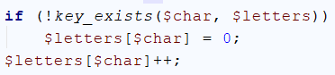

At the end print all key -> values from the array.

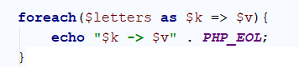

## Count Real Numbers

Read a **list of real numbers** and **print them in ascending order** along with their **number of occurrences**.

### Examples

|  |  |
| --- | --- |
| **Input** | **Output** |
| 8 2.5 2.5 8 2.5 | 2.5 -> 3  8 -> 2 |
| 1.5 5 1.5 3 | 1.5 -> 2  3 -> 1  5 -> 1 |
| -2 0.33 0.33 2 | -2 -> 1  0.33 -> 2  2 -> 1 |

### Hints

Read the input and convert it to array:

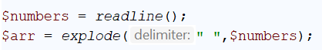

Initialize empty array



Check if the current number is set as key in the array (key_exists()), and if it is- add one to its value.

In other case- set the number as key, with initial value 1.

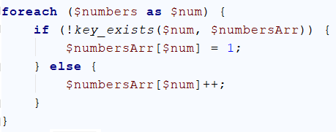

Sort:



And print the array

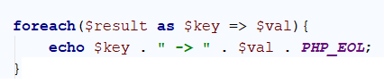

## Odd Occurrences

Write a program that extracts from a given sequence of words all elements that present in it **odd number of times** (case-insensitive).

* Words are given in a single line, space separated.
* Print the result elements in lowercase, in their order of appearance.

### Examples

|  |  |
| --- | --- |
| **Input** | **Output** |
| Java C# PHP PHP JAVA C java | java c# c |
| 3 5 5 hi pi HO Hi 5 ho 3 hi pi | 5 hi |
| a a A SQL xx a xx a A a XX c | a sql xx c |

### Hints

* Use an **associative array** to count **the occurrences of each word (just like in the previous problem)**.
* Pass through all **key-value pairs** in the associative array and append to the results array all **keys** that have **odd value**.
* Print the results list.

## Sum by Town

Read towns and incomes (**on a single line**) and print an array holding the total income for each town (see below). Print the towns in their natural order as object properties.

### Examples

|  |  |
| --- | --- |
| **Input** | **Output** |
| Sofia, 20, Varna, 10, Sofia, 5 | Sofia => 25  Varna => 10 |
| Plovdiv, 40, Pernik, 20, Vidin, 8, Sliven, 44, Plovdiv, 1, Vidin, 7, Chirpan, 0 | Plovdiv => 41  Pernik => 20  Vidin => 15  Sliven => 44  Chirpan => 0 |

## Word Synonyms

Write a program that keeps an associative array with synonyms. The **key** of the array will be the **word**. The **value** will be a **list of all the synonyms of that word**. You will be given a number **n**. On the next **2 * n** lines you will be given a **word** and a **synonym** each on a separate line like this:

* {**word**}
* {**synonym**}

If you get the same word twice just add the new synonym to the list.

Sort the words first by the count of synonyms **(values)** in descending order, and then by alphabetical order of the words **(keys)**

### Output

Print the words in the following format:

**"{word} - {synonym1, synonym2,…, synonymN}"**

### Examples

|  |  |
| --- | --- |
| **Input** | **Output** |
| 3  smart  clever  cute  adorable  cute  charming | cute - adorable, charming  smart - clever |
| 5  task  problem  fashion  model  fashion  look  cute  adorable  task  assignment | fashion - model, look  task - problem, assignment  cute - adorable |

### Hints

* Use **array as associative array** to keep track of all words



* **Read n * 2 lines**
* **Add the word in the associative array if it is not present**

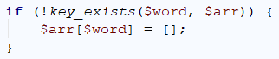

* **Add the synonym as value to the given word**



* **Sort :**

